D.J.SANGHVI COLLEGE OF ENGINEERING

NAME:KARAN.K.SHAH SAP ID:60002120095

DIVISION:EXTC-H SCILAB PRACTICAL:2

DATE:21/02/2013 TITLE: ORDINARY DIFFERENTIAL EQUATION

QUESTION:Solve dy/dx=(y-x)/(y+x) given y(0)=1 & find y(0.5)

PROGRAM:

function **ydot**=f(**x**, **y**),

**ydot**=(**y**-**x**)/(**y**+**x**),

endfunction

yo=1;xo=0;

x=0.5;

y=ode(yo,xo,x,f)

x=0:.01:.5;

y=ode(yo,xo,x,f);

plot(x,y)

title('dy/dx=(y-x)/(y+x)','fontsize',5);

disp('y=');disp(y);

OUTPUT:

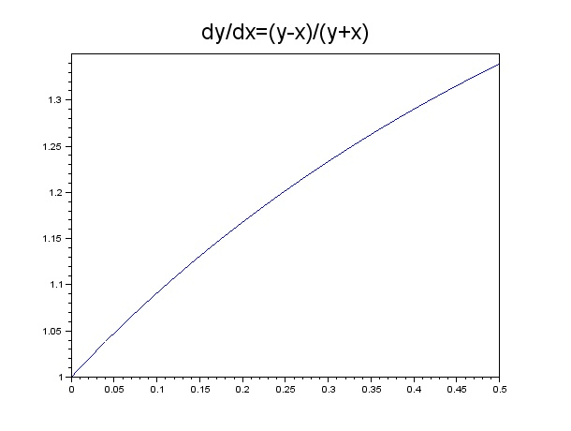

y=

column 1 to 13

1. 1.0099014 1.0196102 1.029134 1.0384793 1.0476524 1.0566591 1.065505 1.074195 1.0827341 1.0911267 1.0993773 1.1074898

column 14 to 25

1.1154681 1.1233159 1.1310365 1.1386332 1.1461092 1.1534674 1.1607107 1.1678416 1.1748629 1.1817768 1.1885859 1.1952922

column 26 to 37

1.201898 1.2084054 1.2148162 1.2211324 1.2273557 1.233488 1.239531 1.2454861 1.2513551 1.2571393 1.2628403 1.2684595

column 38 to 49

1.273998 1.2794574 1.2848388 1.2901435 1.2953726 1.3005272 1.3056085 1.3106175 1.3155552 1.3204227 1.3252209 1.3299507

column 50 to 51

1.3346132 1.339209